Extra 15-2 Format the data in a FormView control

In this exercise, you’ll modify an application that uses a FormView control for maintaining customers. That will give you an idea of the flexible layouts you can create using this control.

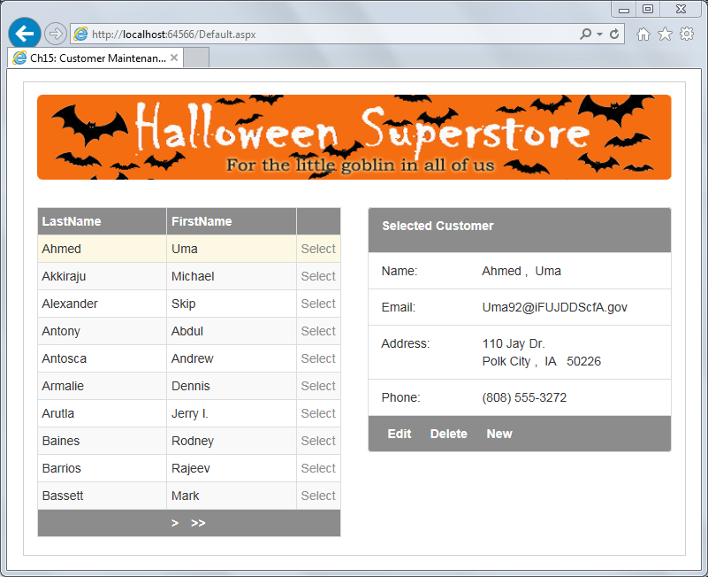

In this exercise, if a step tells you to view your changes, save the changes in Visual Studio, switch to the running browser, and then refresh the browser.

1. Open the XEx15CustMaintFormView application in your exercises_extra directory, and run it to see what it looks like. Leave the browser running when you’re done.
2. Format the Item template of the FormView control so the items are displayed in a Bootstrap list group. To do that, you can assign the list-group and list-group-item classes to the appropriate div elements in the template. You can use the EditItem or InsertItem template as a guide. Also, assign the bg-halloween class to the first and last list items so the FormView control resembles the GridView control, as shown above. View your changes.
3. Adjust the Item template so the first name and last name are combined in a single list item that’s labeled “Name”. Use this format:   
     
    LastName, FirstName  
     
   Use a non-breaking space (&nbsp;) to add a space after the comma. View your changes.
4. Adjust the Item template so the address, city, state, and zip code are combined in a single list item that’s labeled “Address”. Use this format:  
     
    Address  
    City, State ZipCode  
     
   To achieve this format, you’ll need to have each line in its own row div. As before, use a non-breaking space to add spaces. View your changes.
5. Run the application to see how all the different templates look.